

**How to manage website**

**How to customize website header**

-How to change website logo and favicon  
Go to Admin > Appearance > Customize as shown in the screenshot below.

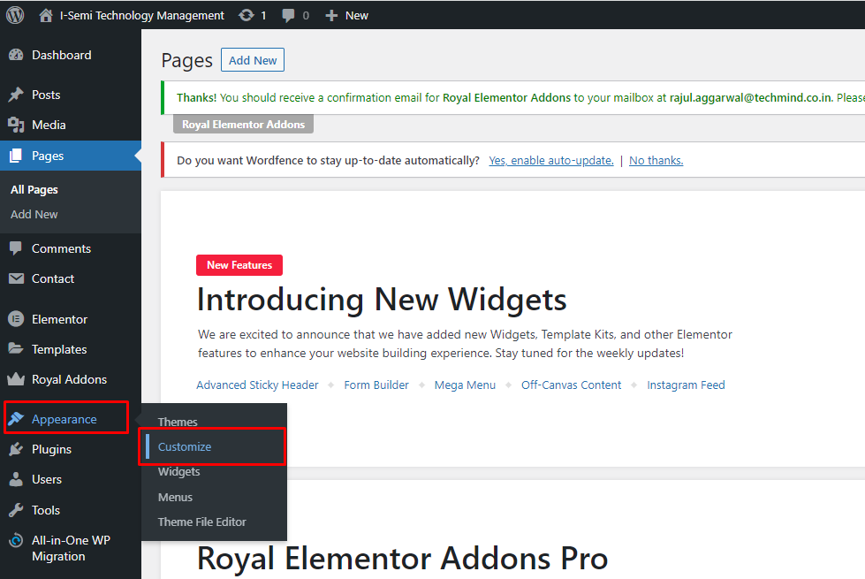

It will take you to the customizer page of this website then click on Site Identity option as shown in the screenshot below.

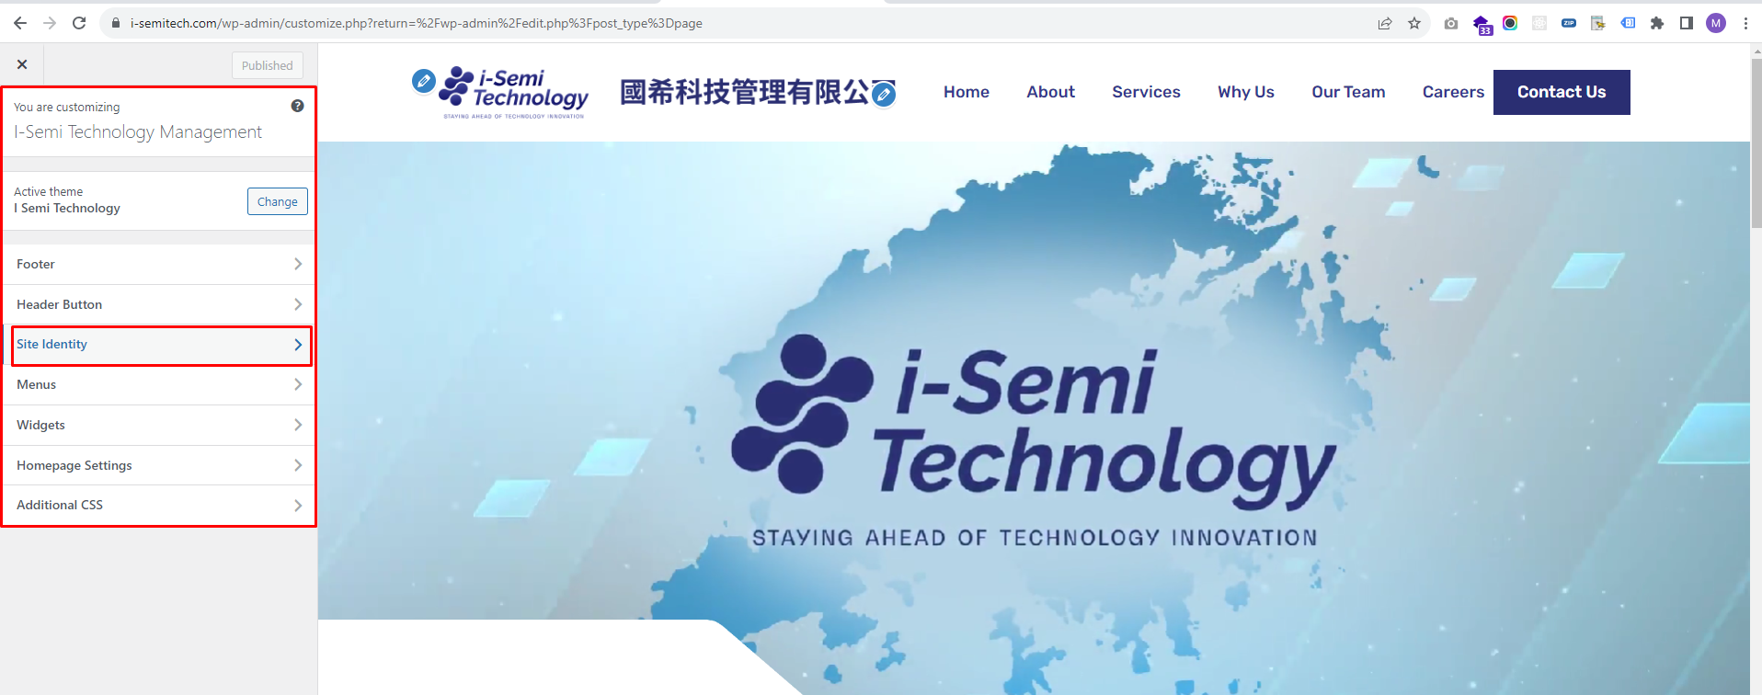

You will see the option to change the logo and favicon, and you can make the changes now as shown in the screenshot below.

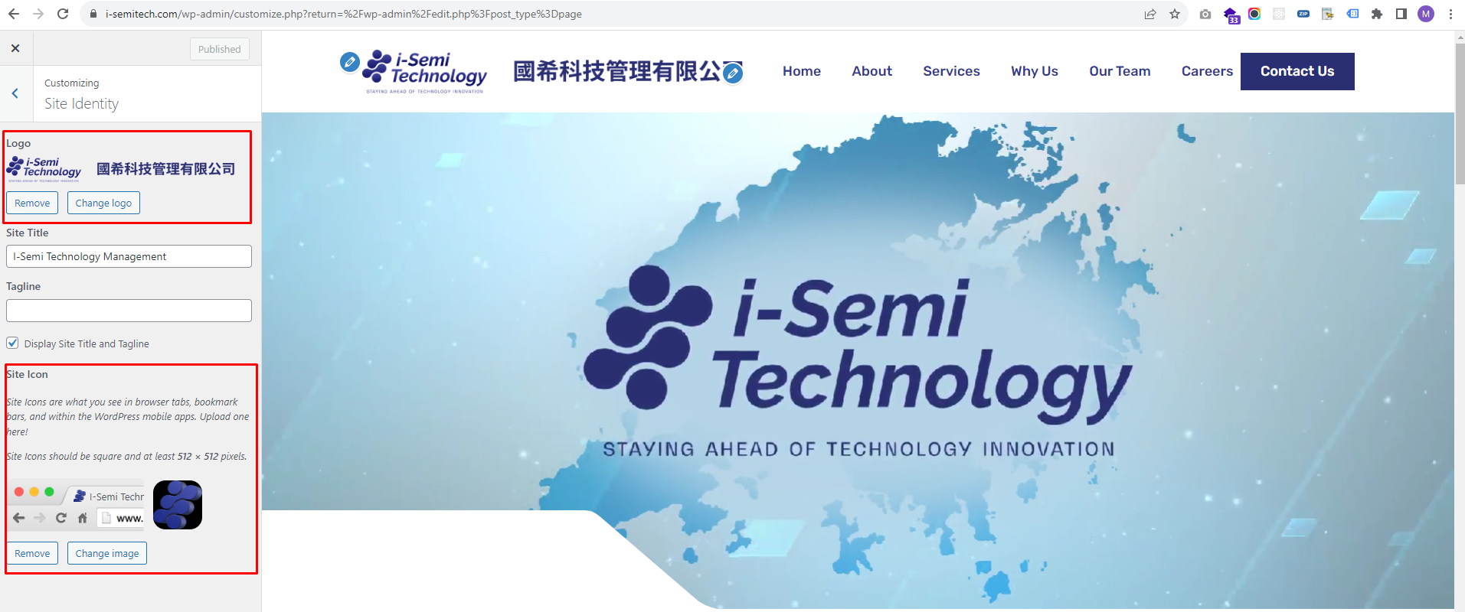

-To change the text and URL of the **Contact Us** button in the header, click on the 'Header Button' option in the customizer as shown in the screenshot below.

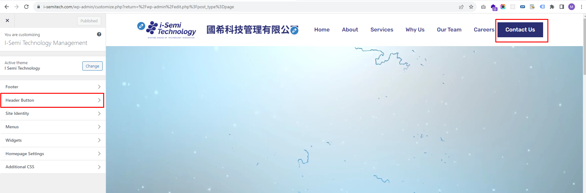

You will see the option to change Text and URL of the button, and you can make the changes now as shown in the screenshot below.

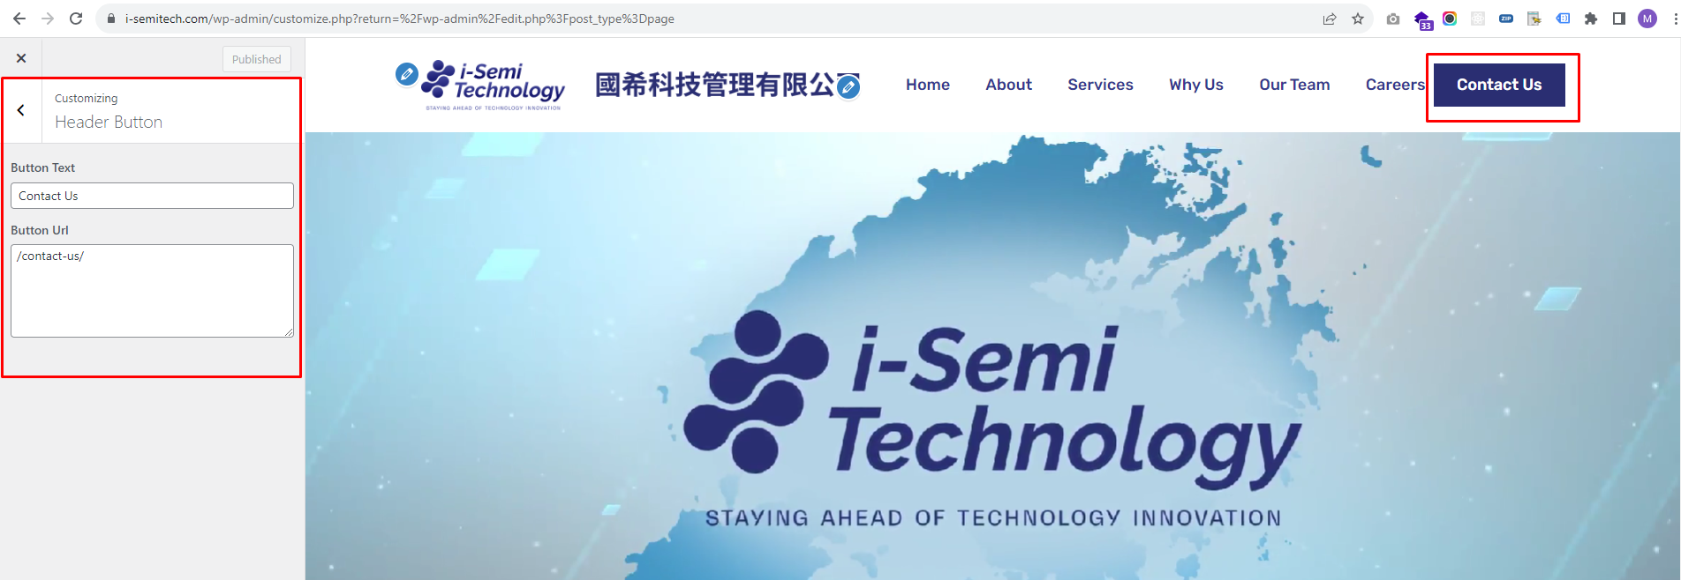

-To manage the **Navigation Menu** in the header, click on the 'Menus' option in the customizer as shown in the screenshot below.

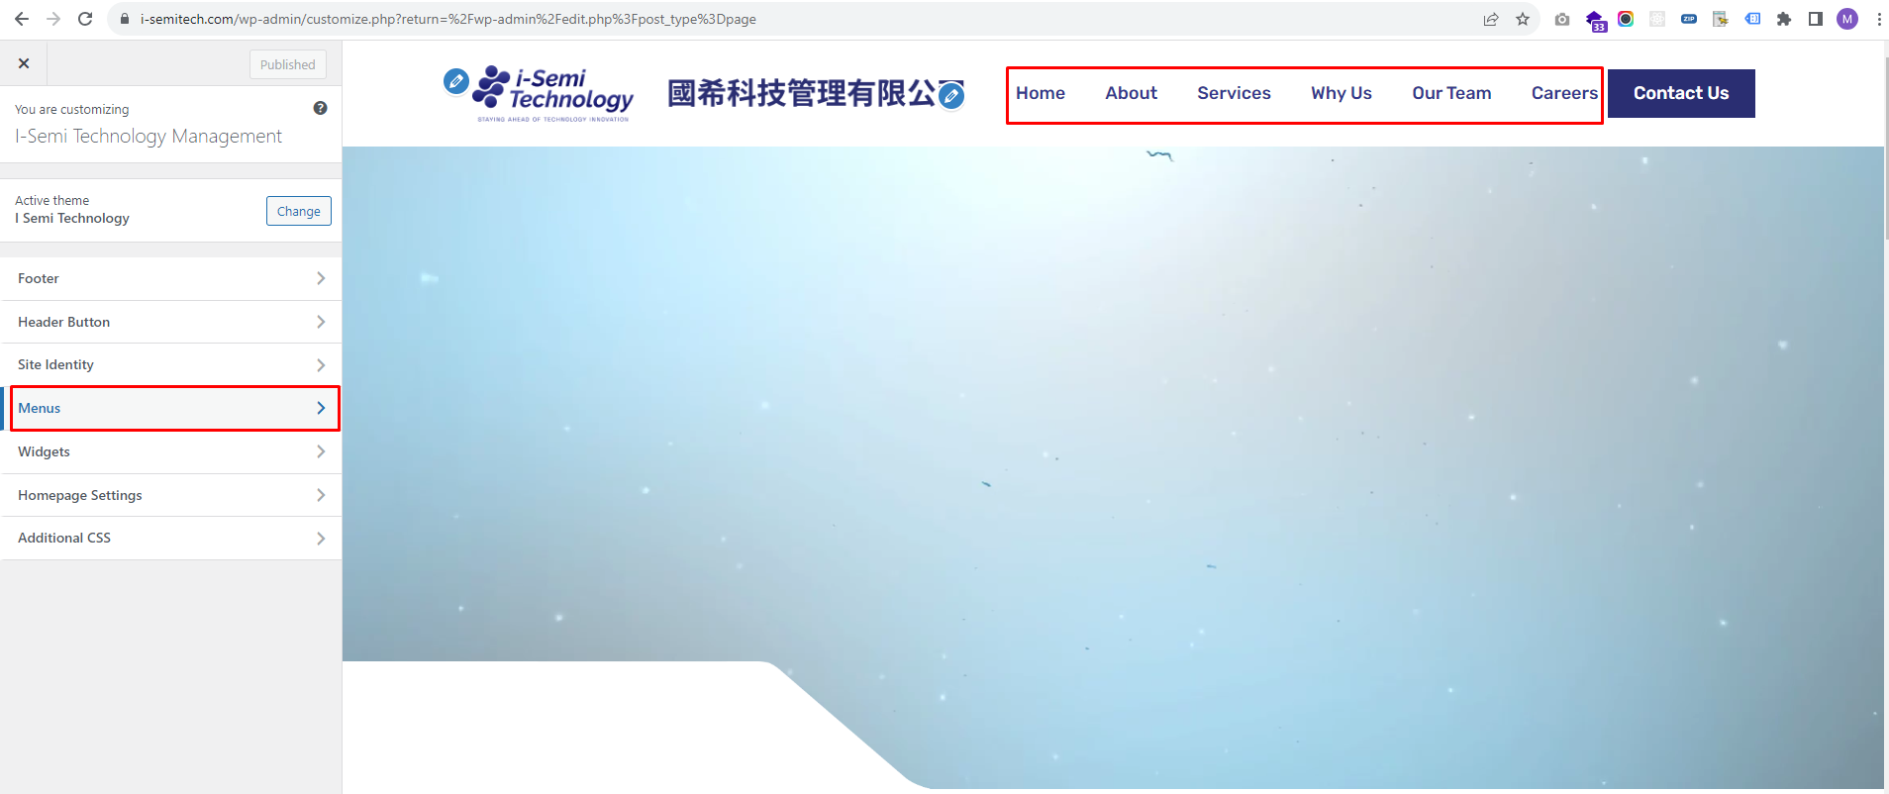

Then Click on the 'Primary Menu' option as shown in the screenshot below.

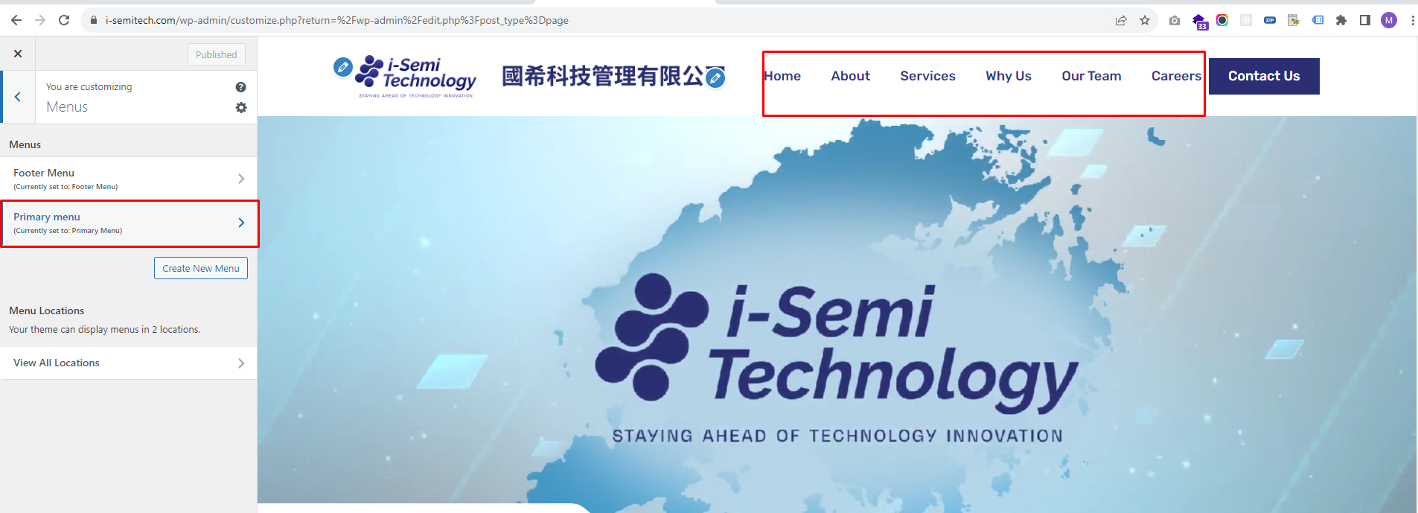

You can change the order, add, or delete menu items for Navigation from here as shown in the screenshot below.

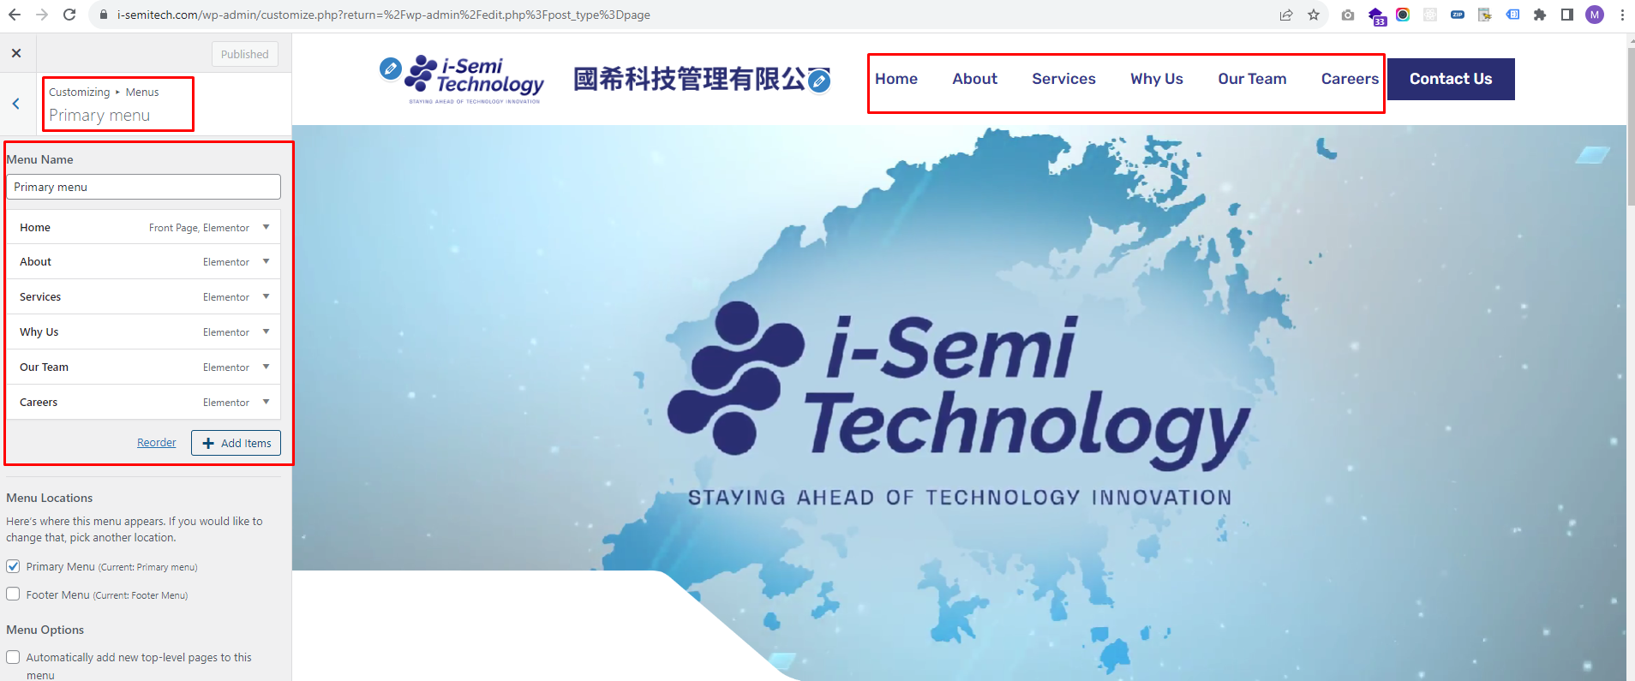

After making any changes in the customizer, click on the 'Publish' button, and your changes will be updated as shown in the screenshot below

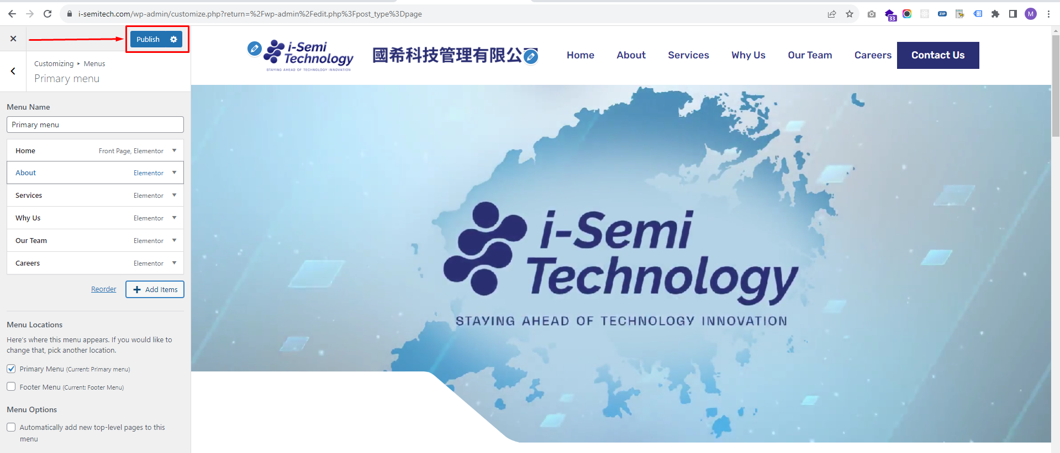

**How to customize website Footer**

-To make any changes inside the website's footer, you need to click on the 'Footer' option on the Customizer page as shown in the screenshot below.

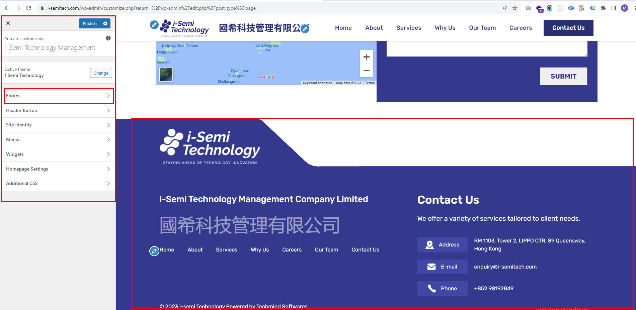

You can click on the option according to the part of the footer where you want to make changes and modify it accordingly as shown in the screenshot below.

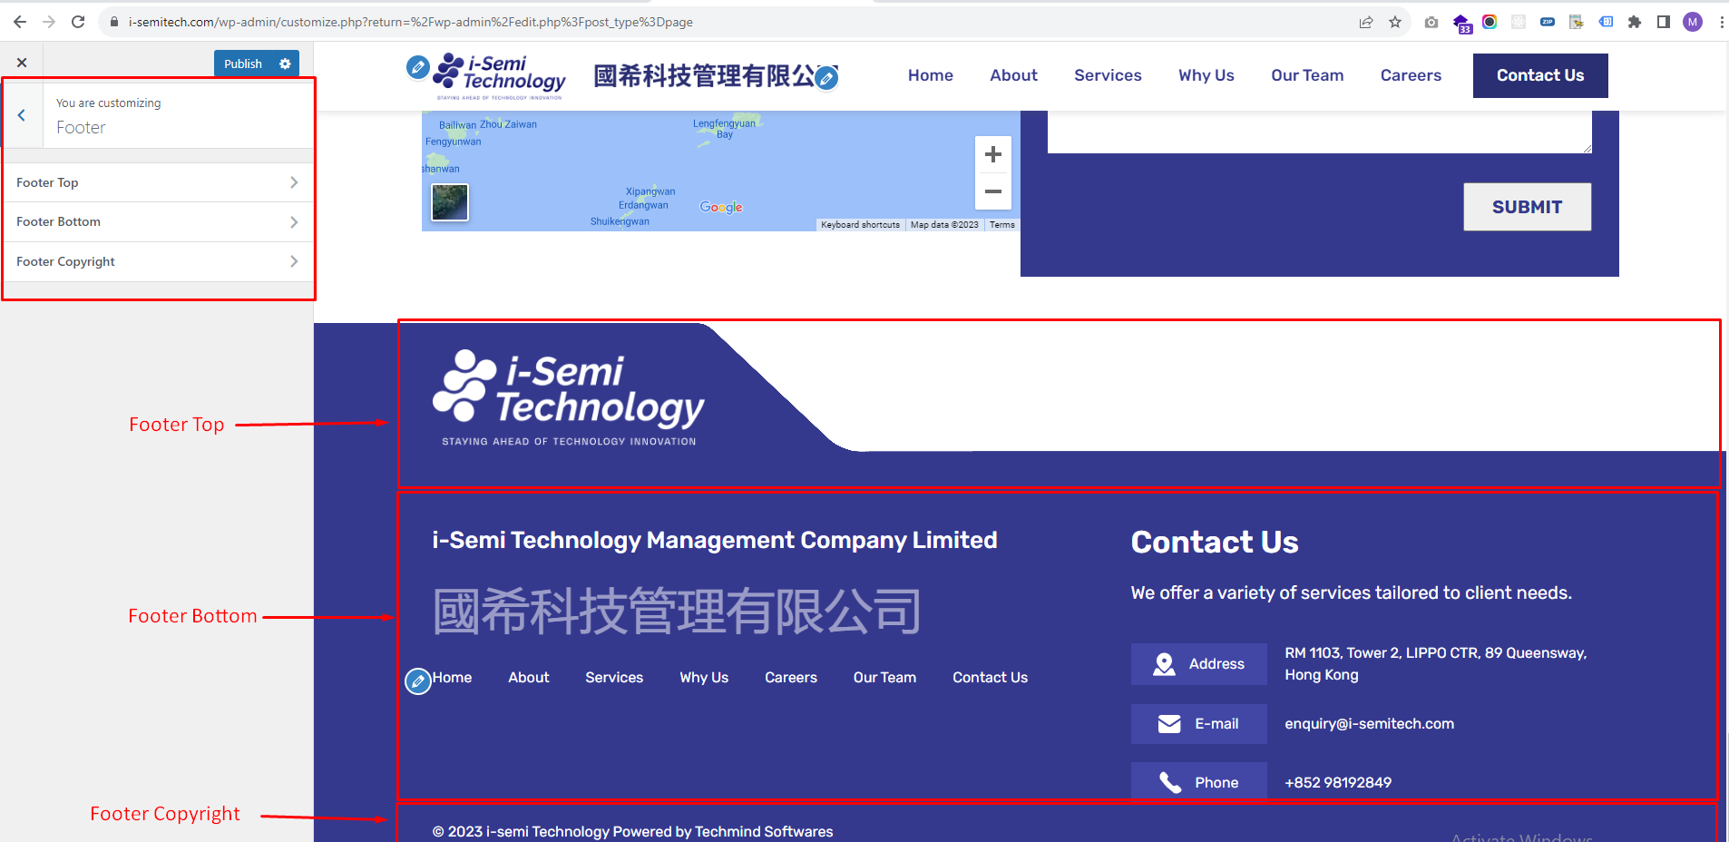

**Footer Top**

You will find the option to change the logo within the footer top, and you can change the logo from there as shown in the screenshot below.

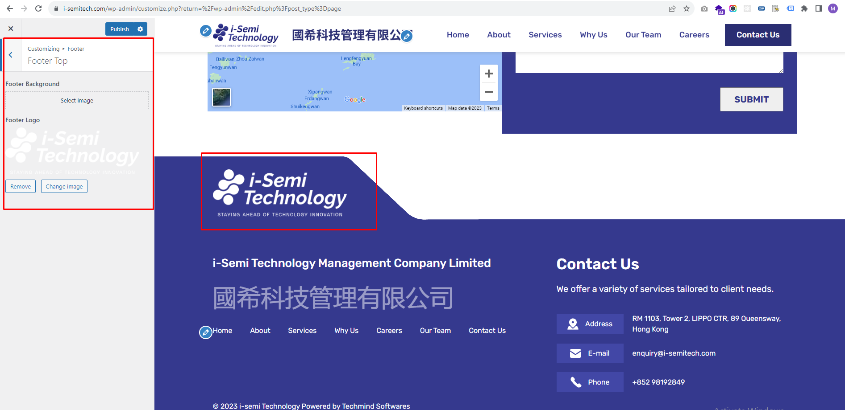

**Footer Bottom**

To make changes in the bottom part of the footer, you will find all the fields in the 'Footer Bottom' option, and you can make changes there.as shown in the screenshot below.

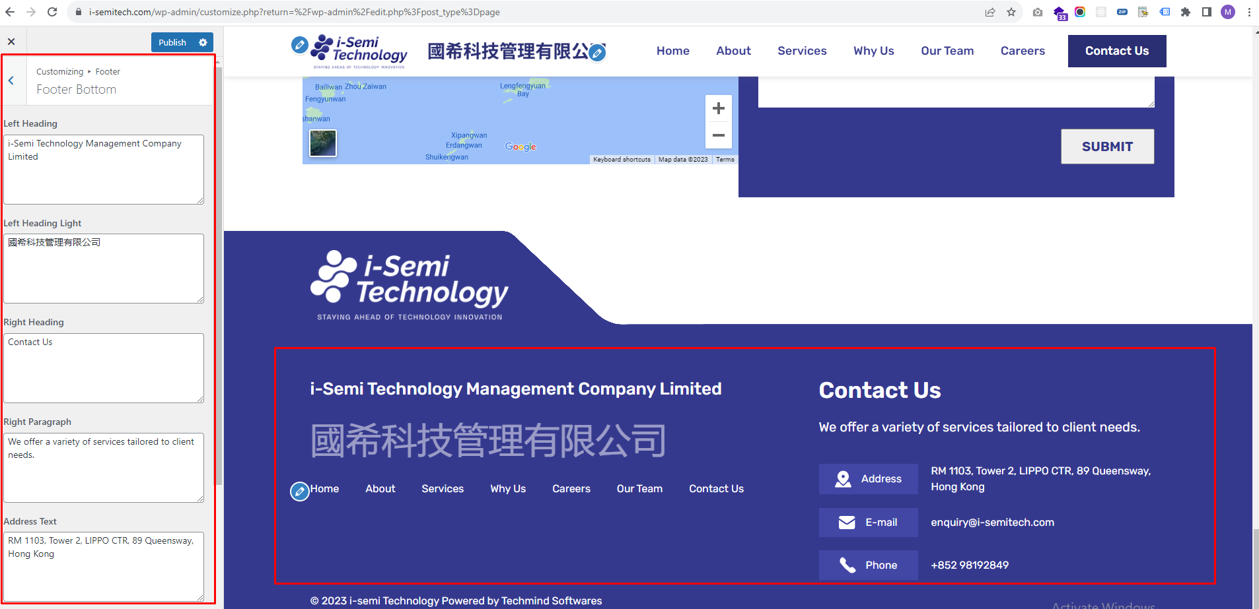

**Footer Copyright**

To make changes in the Copyright part of the footer, you will find all the fields in the 'Footer Copyright’ option, and you can make changes there as shown in the screenshot below.

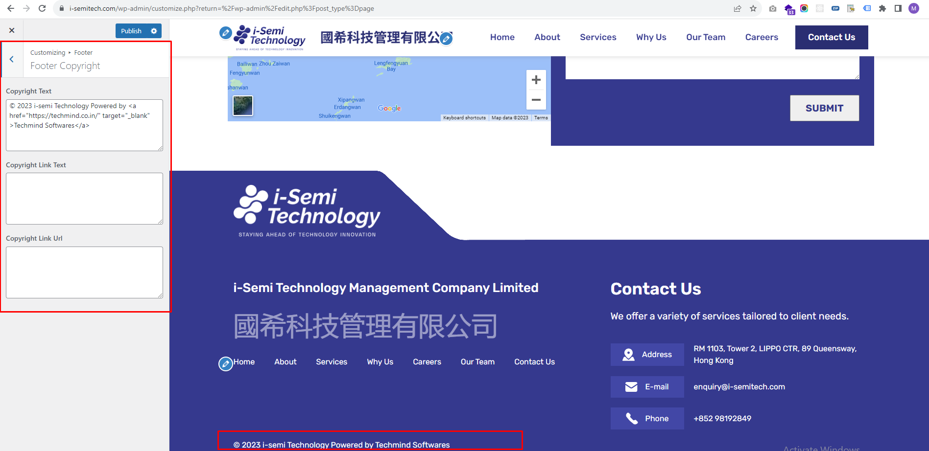

**Home Page**

-To change the video in the banner, click on the video, and you will find options in the left sidebar to change the to change the video. Make the changes and update as shown in the screenshot below.

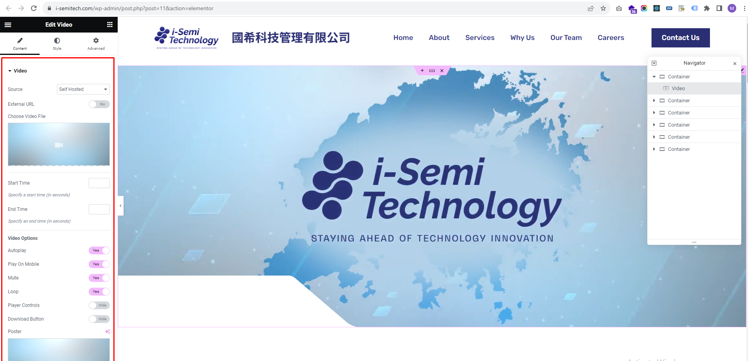

-To change the image in the **'i-Semi Technology Management Company Limited'** section, click on the image, and you will find options in the left sidebar to change the image. Make the changes and update as shown in the screenshot below.

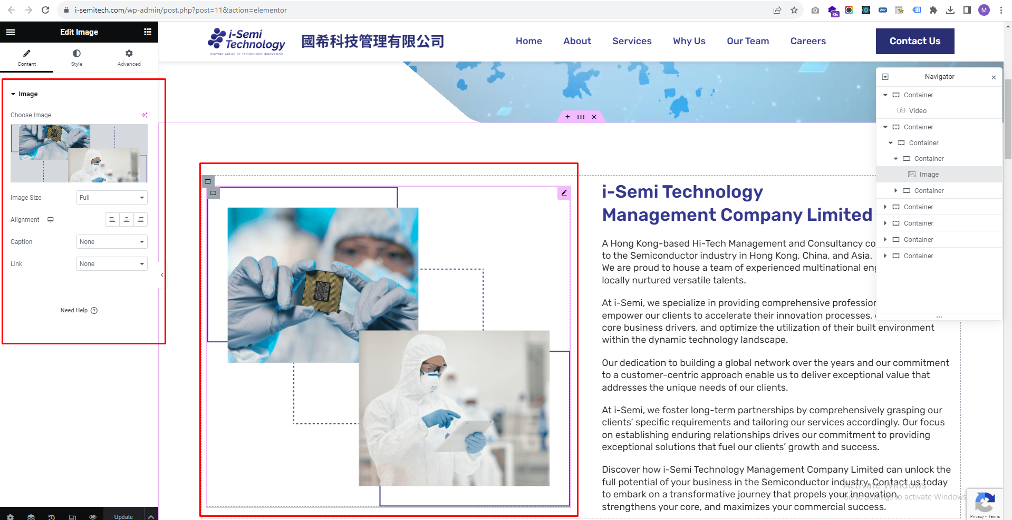

-To change the Heading or text in the **'i-Semi Technology Management Company Limited'** section, click on the Heading or paragraph, and you will find options in the left sidebar to change the corresponding Heading or Paragraph Text to where you clicked. Make the changes and update as shown in the screenshot below.

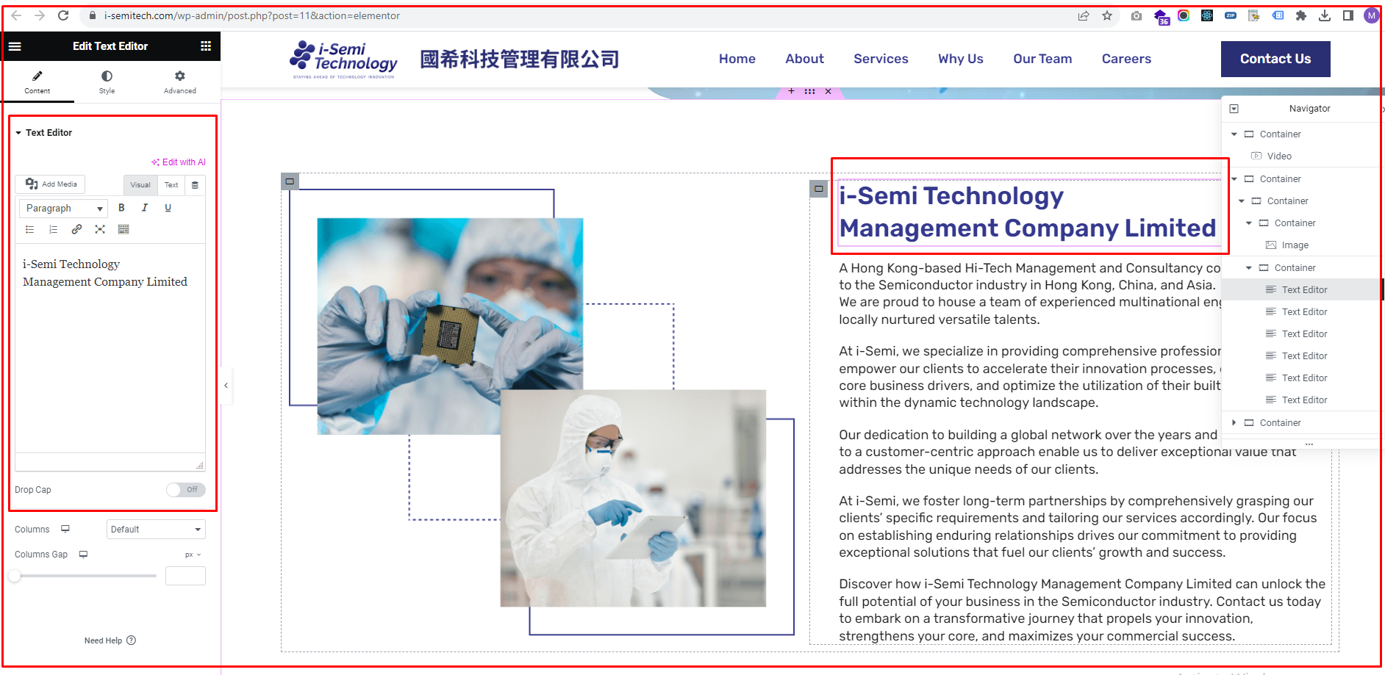

-To change the text and URL of the button in the 'Our Services' section, click on the button. You will find fields in the left sidebar where you can change the text and URL. Make the changes there and update as shown in the screenshot below.

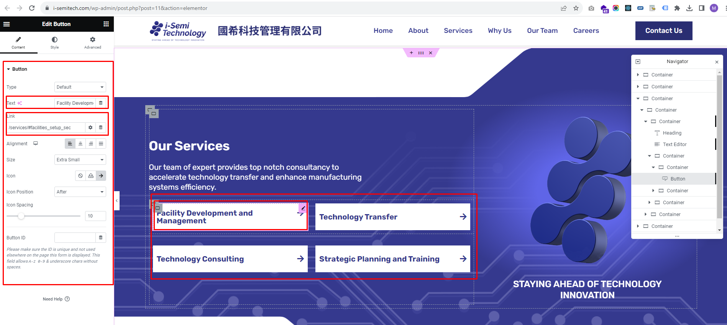

-To change the animated logo or text in the 'Our Services' section, click on it. You will find HTML code in the left sidebar for changing the image by replacing the image URL. To change the text, you can modify the text inside the <h4> tag and then update as shown in the screenshot below.

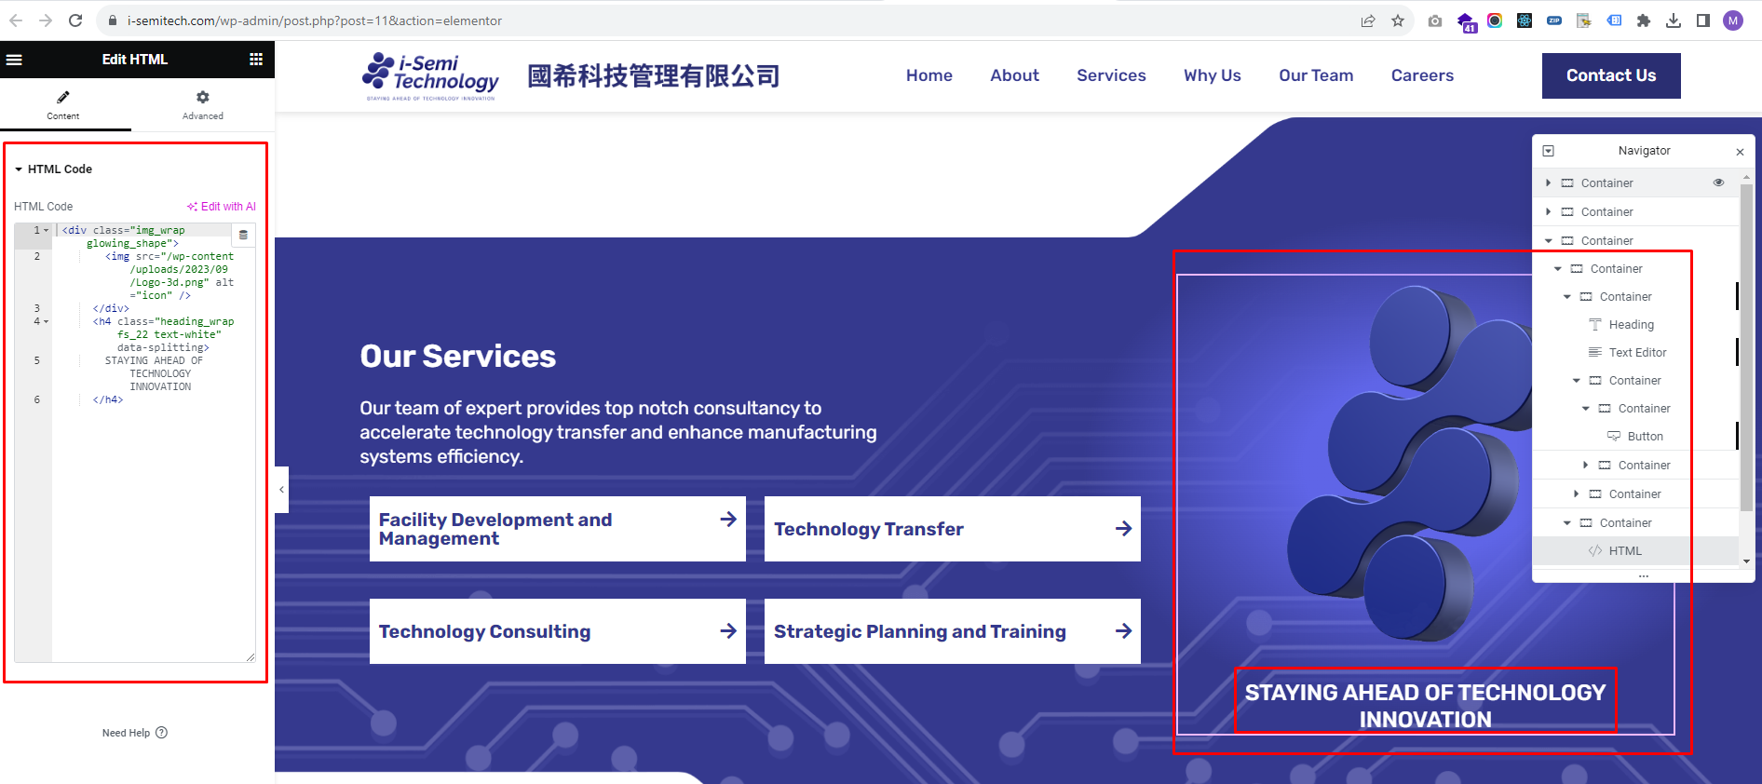

- To change the content in the **'Why Partner with Us'** section, click on the element you want to edit. You will then see options in the left sidebar that allow you to make the desired changes. After making the changes, you can update them as shown in the screenshot below.

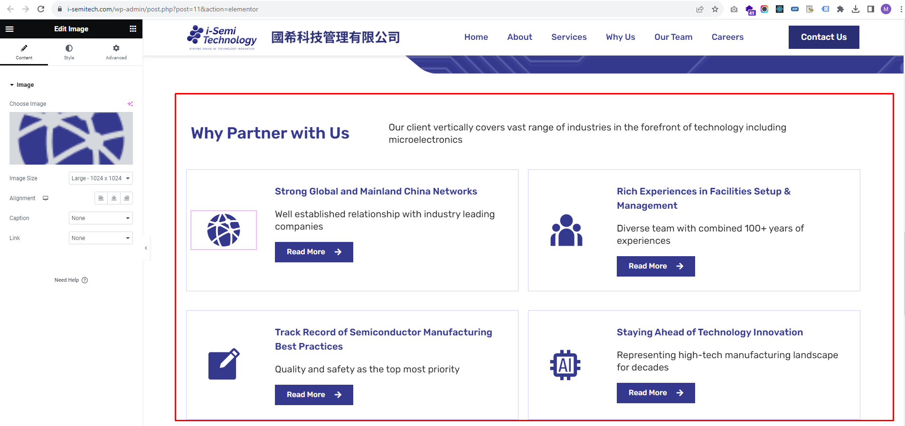

-To change the address in the map, click on it, and you will find options in the left sidebar to make the necessary changes. After making the changes, you can update them.

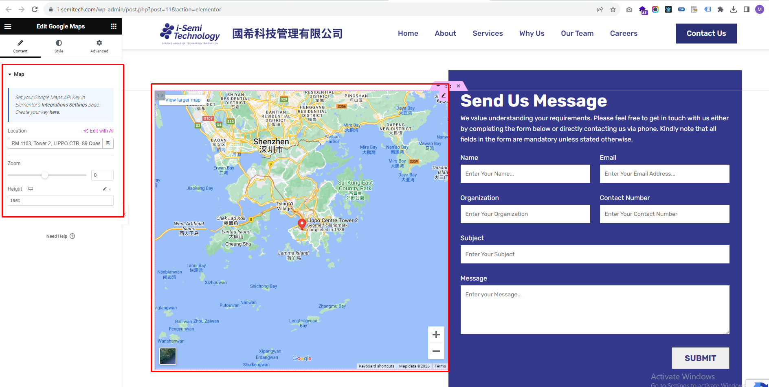

-To change the text or field in Contact form

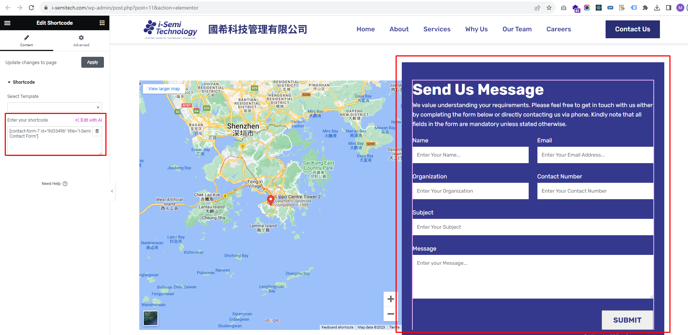

Go to Admin > Contact > Contact Forms

Now you will see **I-Semi Contact Form** as shown in the screenshot below.

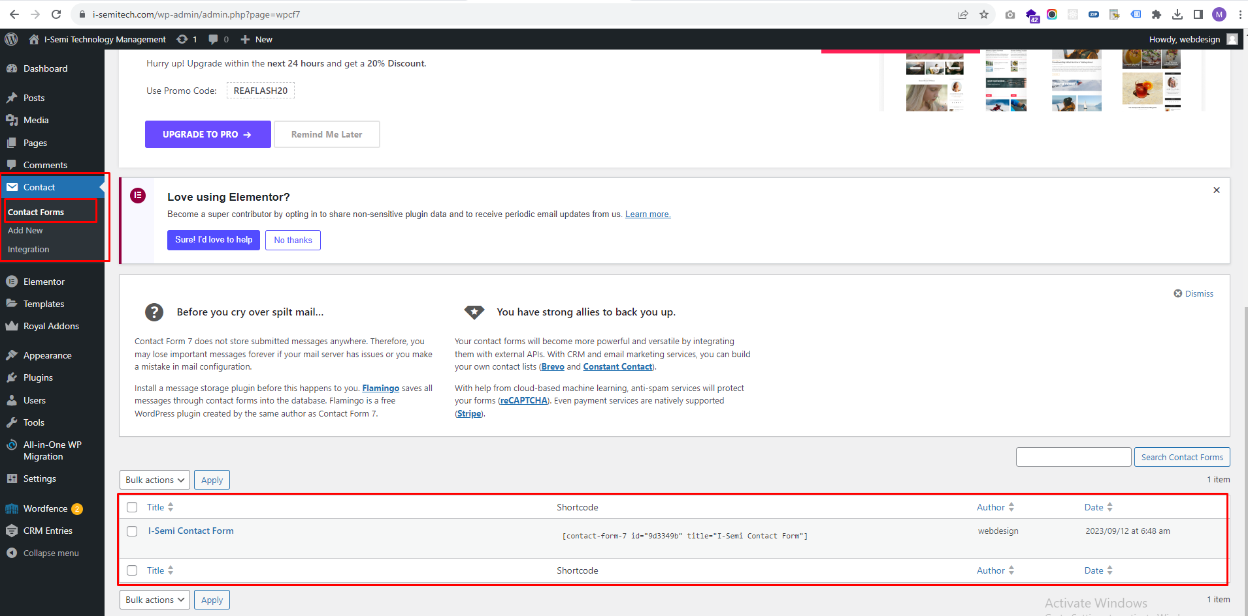

Click on it and make the desired changes eg: textual changes or add / remove form fields . After making the changes, you can update them as shown in the screenshot below.

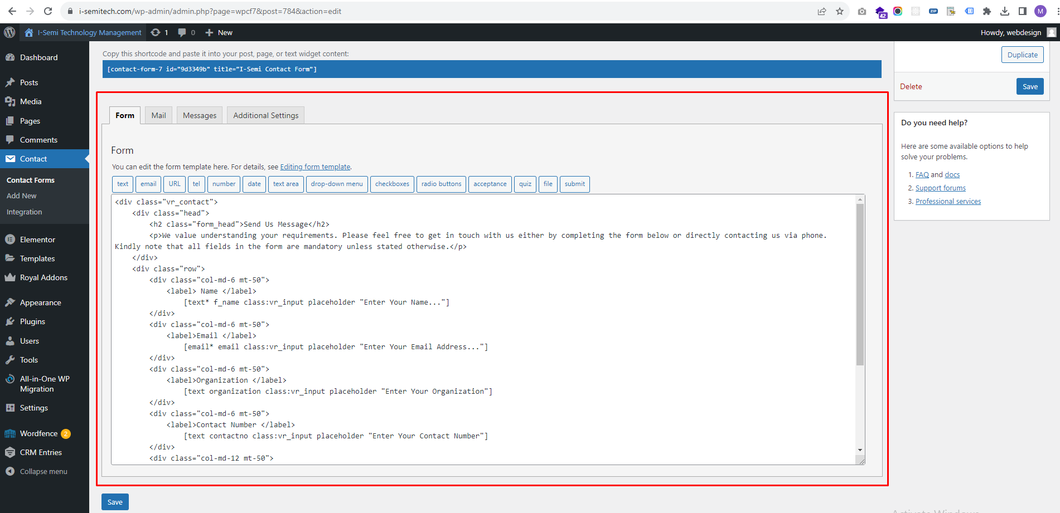

**About Page**

-To change the Banner image, click on it and you will find options in the left sidebar to change the banner image. Make the changes and update as shown in the screenshot below

.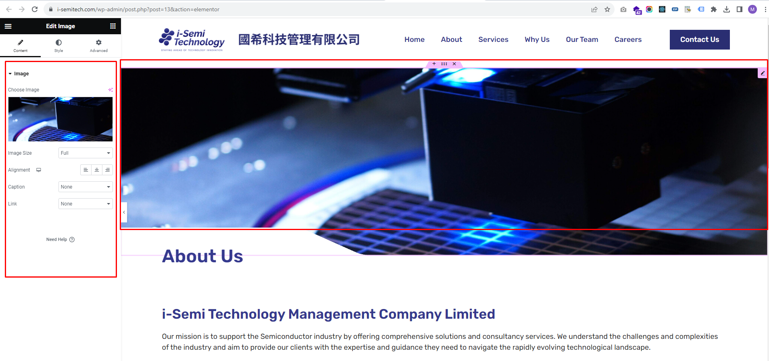

-To change the Text or image in the section, click on the Heading, paragraph or image, and you will find options in the left sidebar to change the corresponding Heading,Paragraph Text or image to where you clicked. Make the changes and update as shown in the screenshot below.

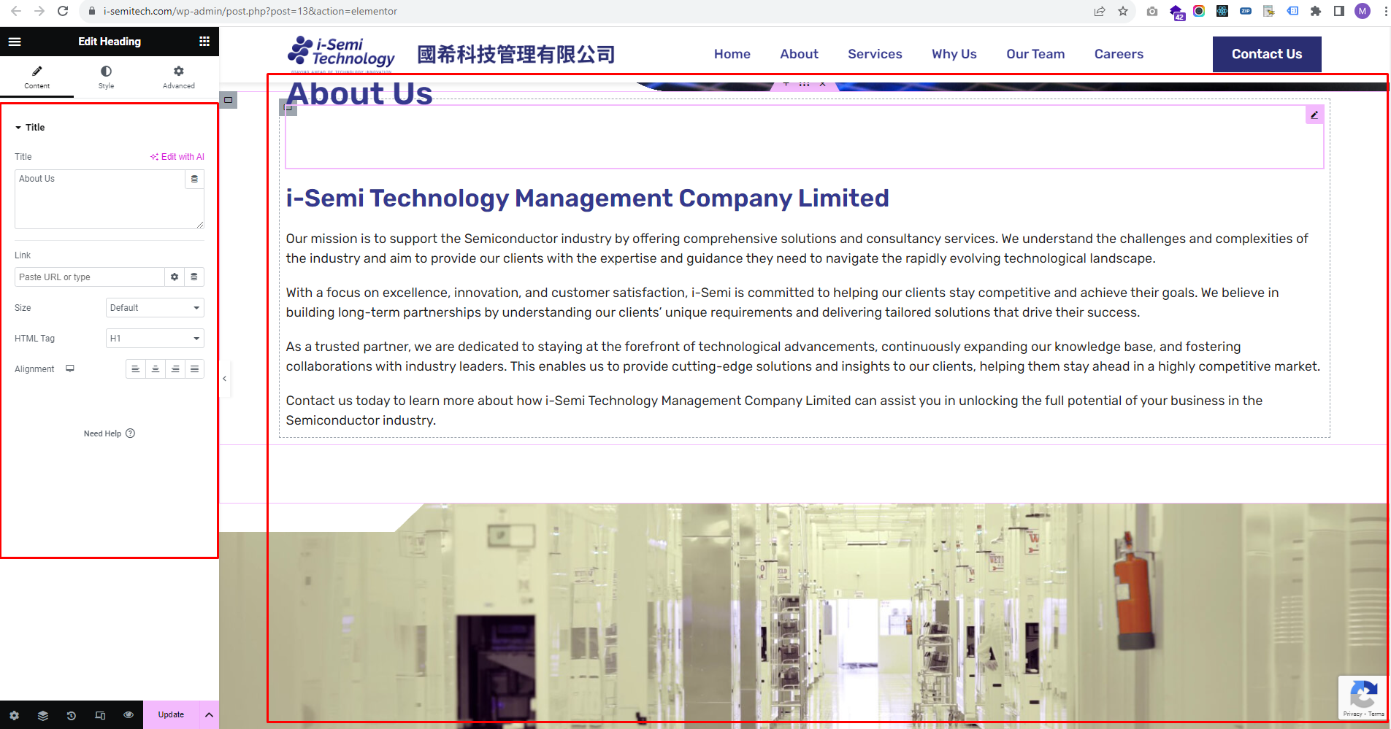

**Services Page**

- To Change services background video

Click on Service section’s 6 dots icon then inside **Navigator sidebar** your section will be selected click on it and expand the section then you will find video as shown in the screenshot below.

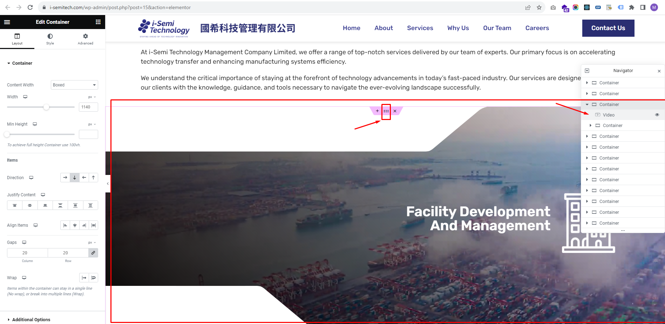

Click on video and you will find options in the left sidebar to change the service video. Make the changes and update as shown in the screenshot below

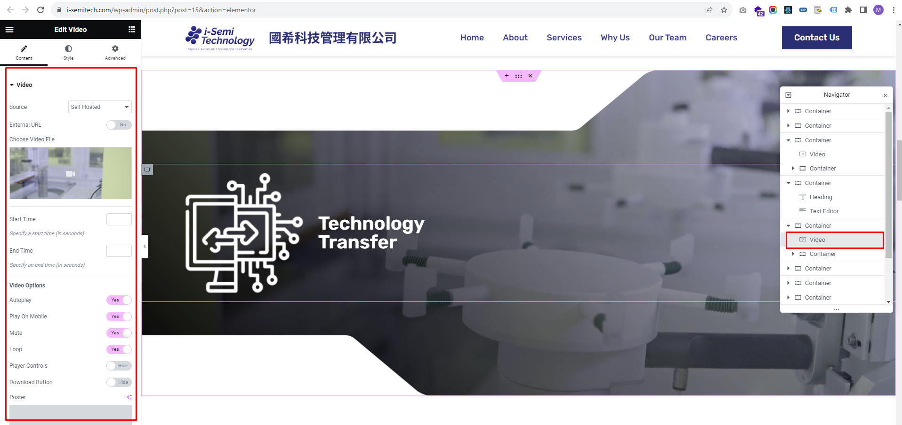

-To change the Text or image in the section, click on the Heading, paragraph or image, and you will find options in the left sidebar to change the corresponding Heading,Paragraph Text or image to where you clicked. Make the changes and update as shown in the screenshot below.

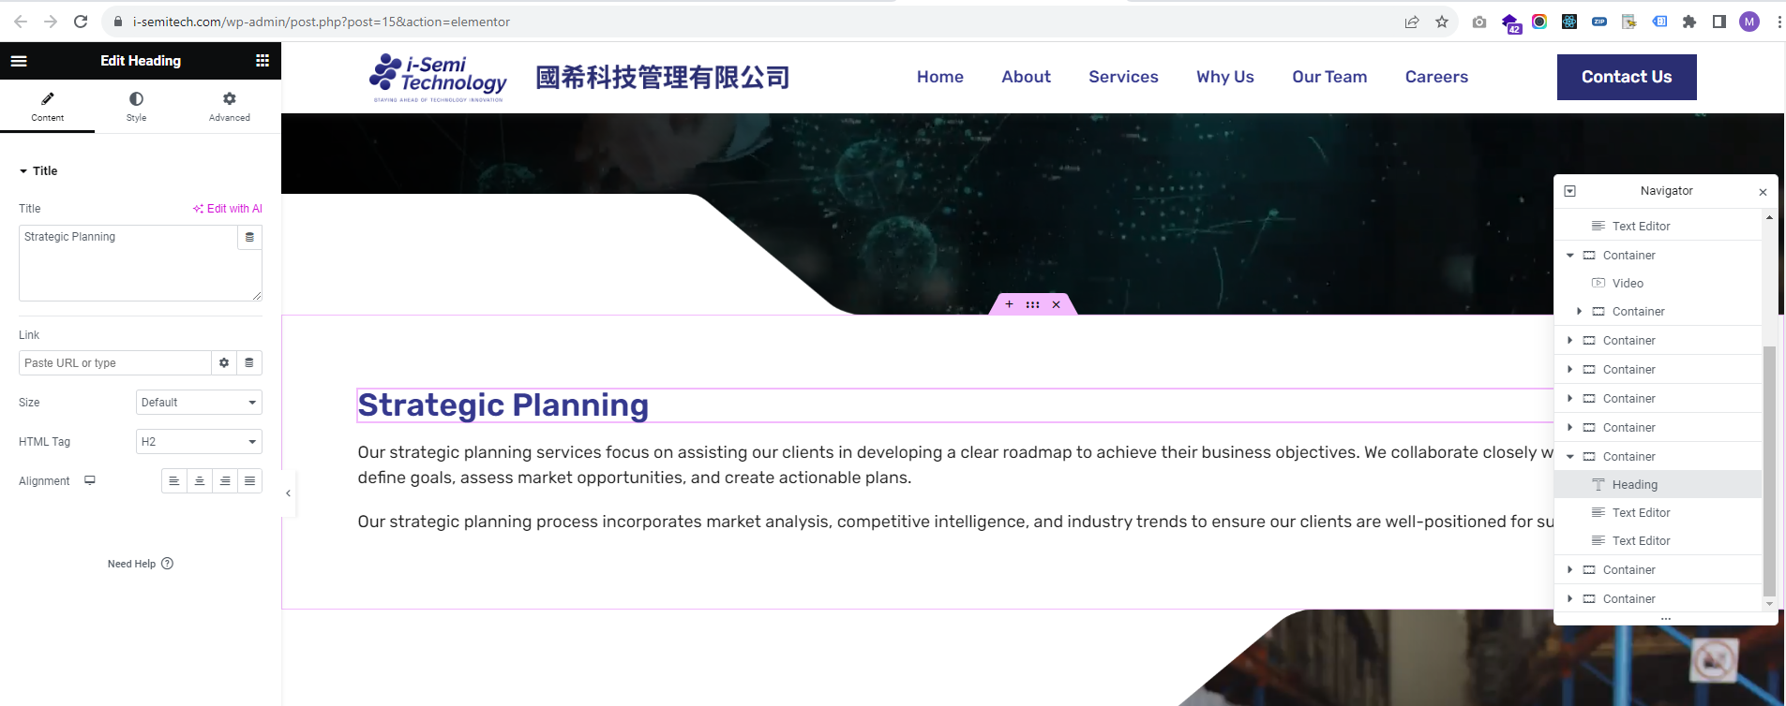

**Why us Page**

-To change the Text or image in the section, click on the Heading, paragraph or image, and you will find options in the left sidebar to change the corresponding Heading,Paragraph Text or image to where you clicked. Make the changes and update as shown in the screenshot below.

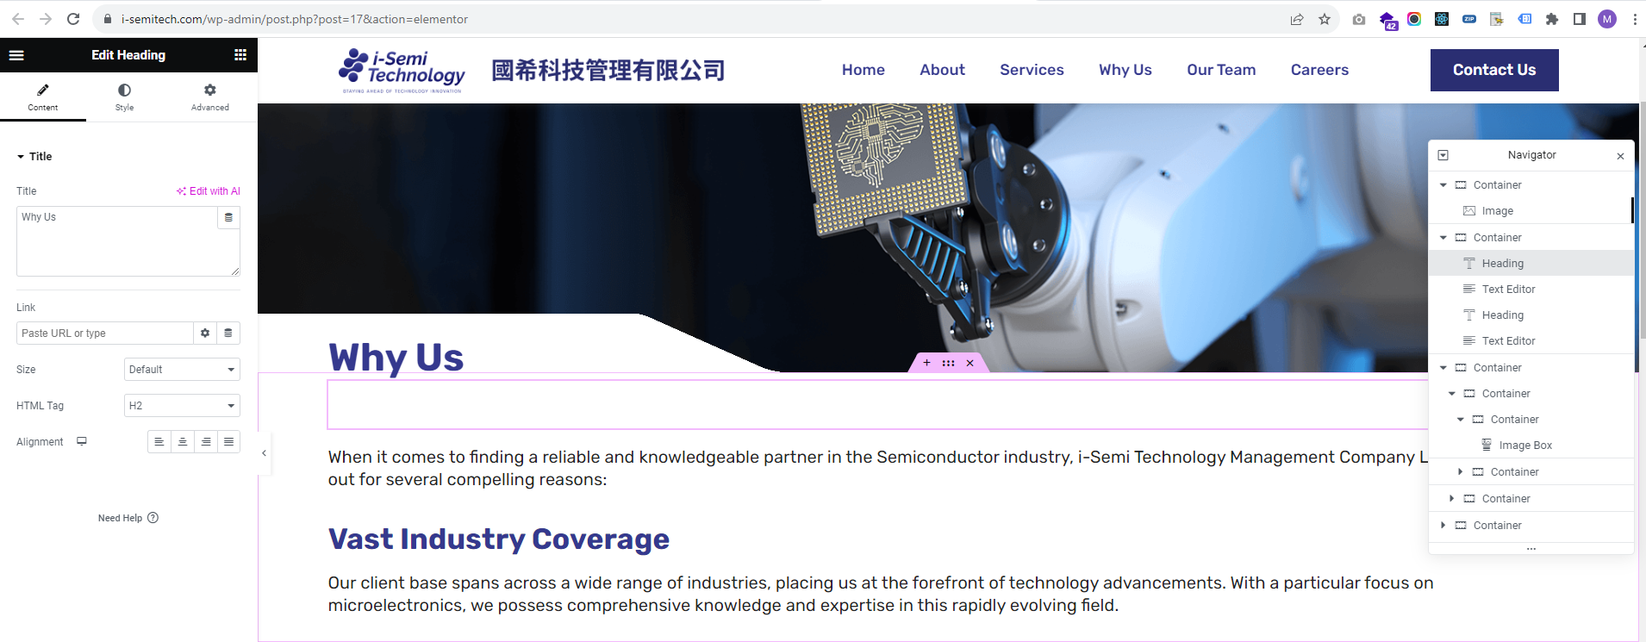

-To change the content in the content box, click on it. You will find fields in the left sidebar to change the icon, heading and text. Make the desired changes there and then update.

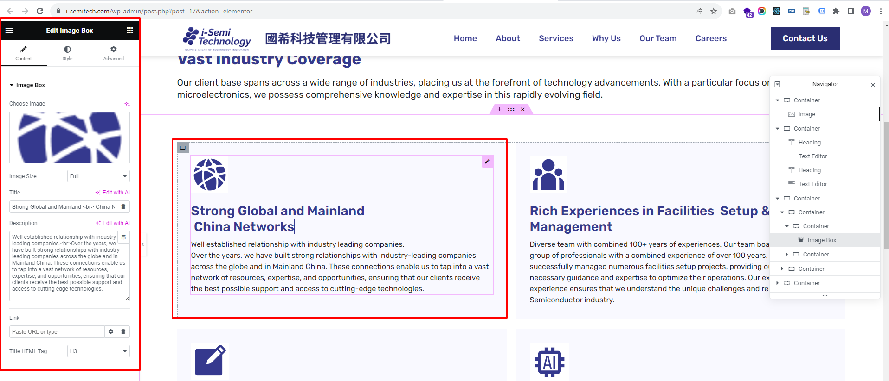

**Team Page**

-To change the Text or image in the section, click on the Heading, paragraph or image, and you will find options in the left sidebar to change the corresponding Heading,Paragraph Text or image to where you clicked. Make the changes and update as shown in the screenshot below.

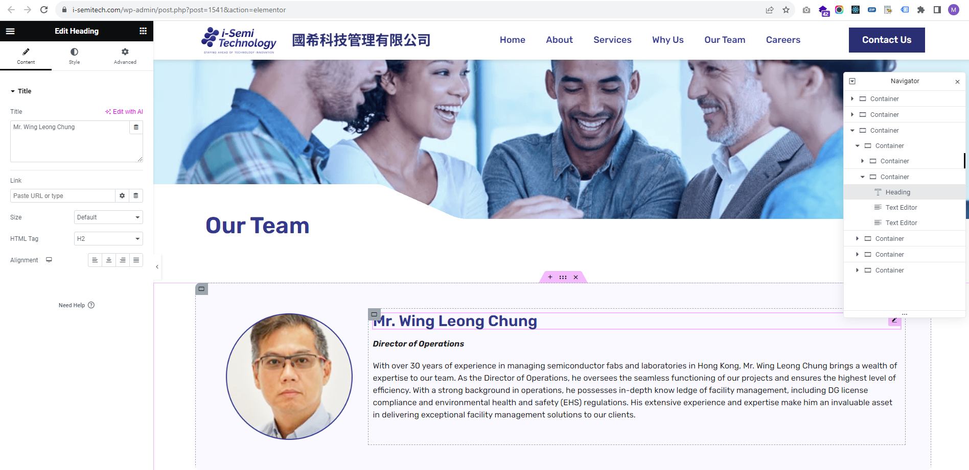

**Career Page**

-To change the Text or image in the section, click on the Heading, paragraph or image, and you will find options in the left sidebar to change the corresponding Heading,Paragraph Text or image to where you clicked. Make the changes and update as shown in the screenshot below.

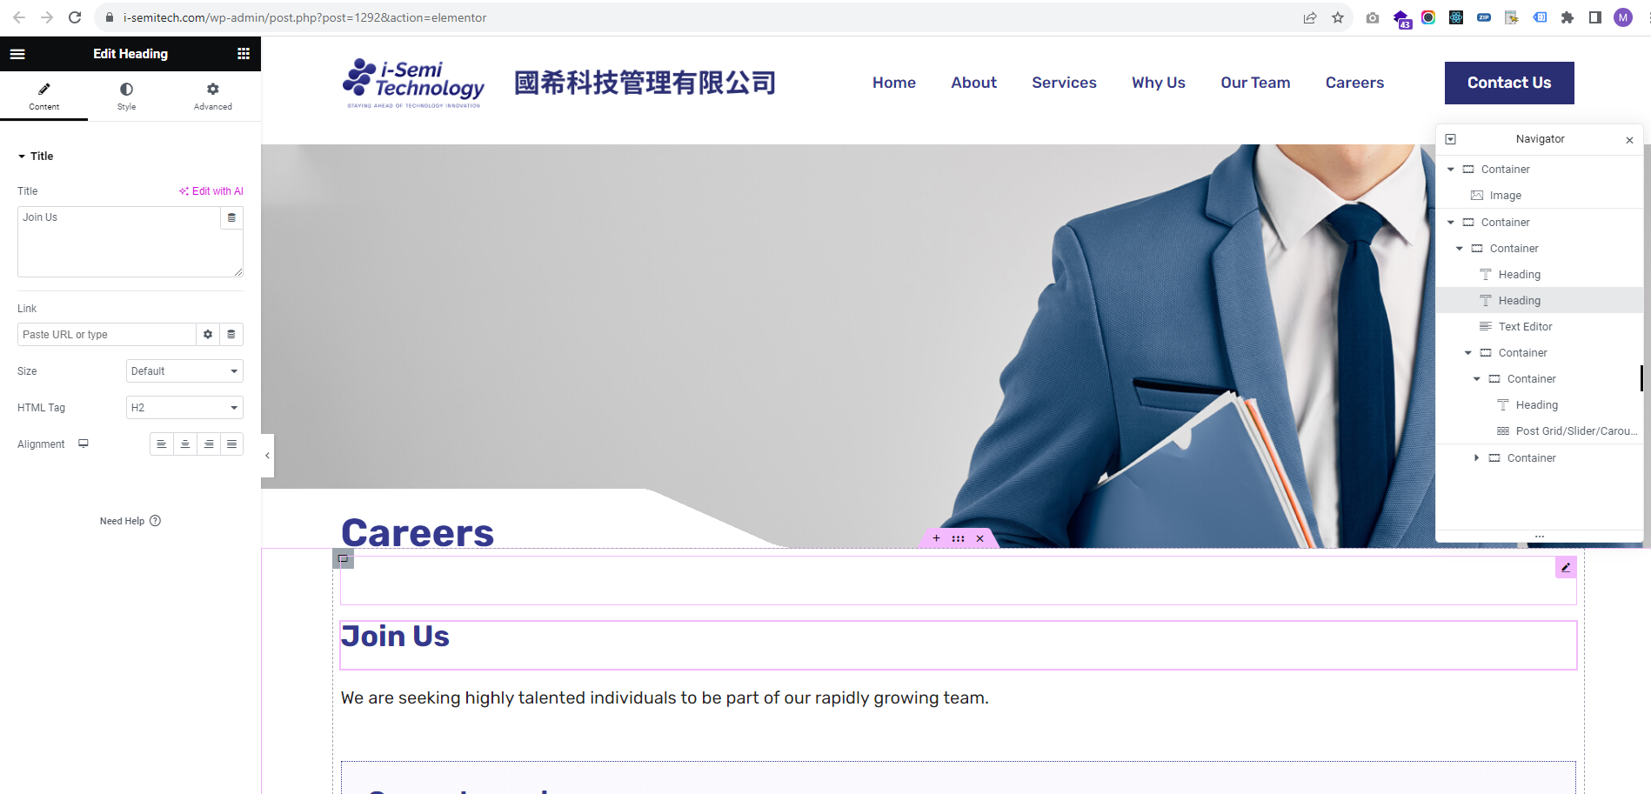

These **'Current Openings'** are being **dynamically** sourced from the default post type **'post'** as shown in the screenshot below.

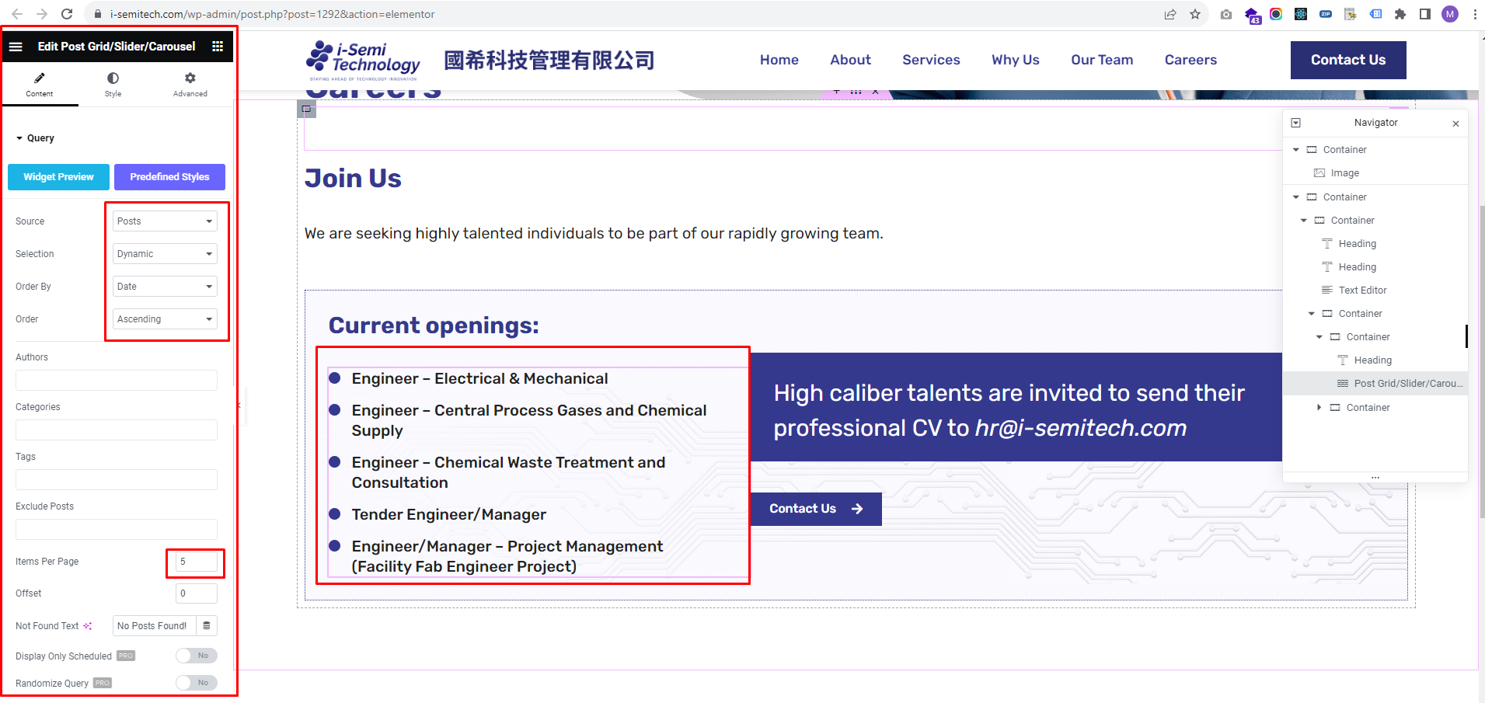

To change the **Current Openings** title or single post content of these posts, you will need to edit them.

Go to Admin > Posts > All Posts > Your openings posts are there

Click on them and make the changes and update as shown in the screenshot below.

Please check all **Current Openings** posts as shown in the screenshot below.

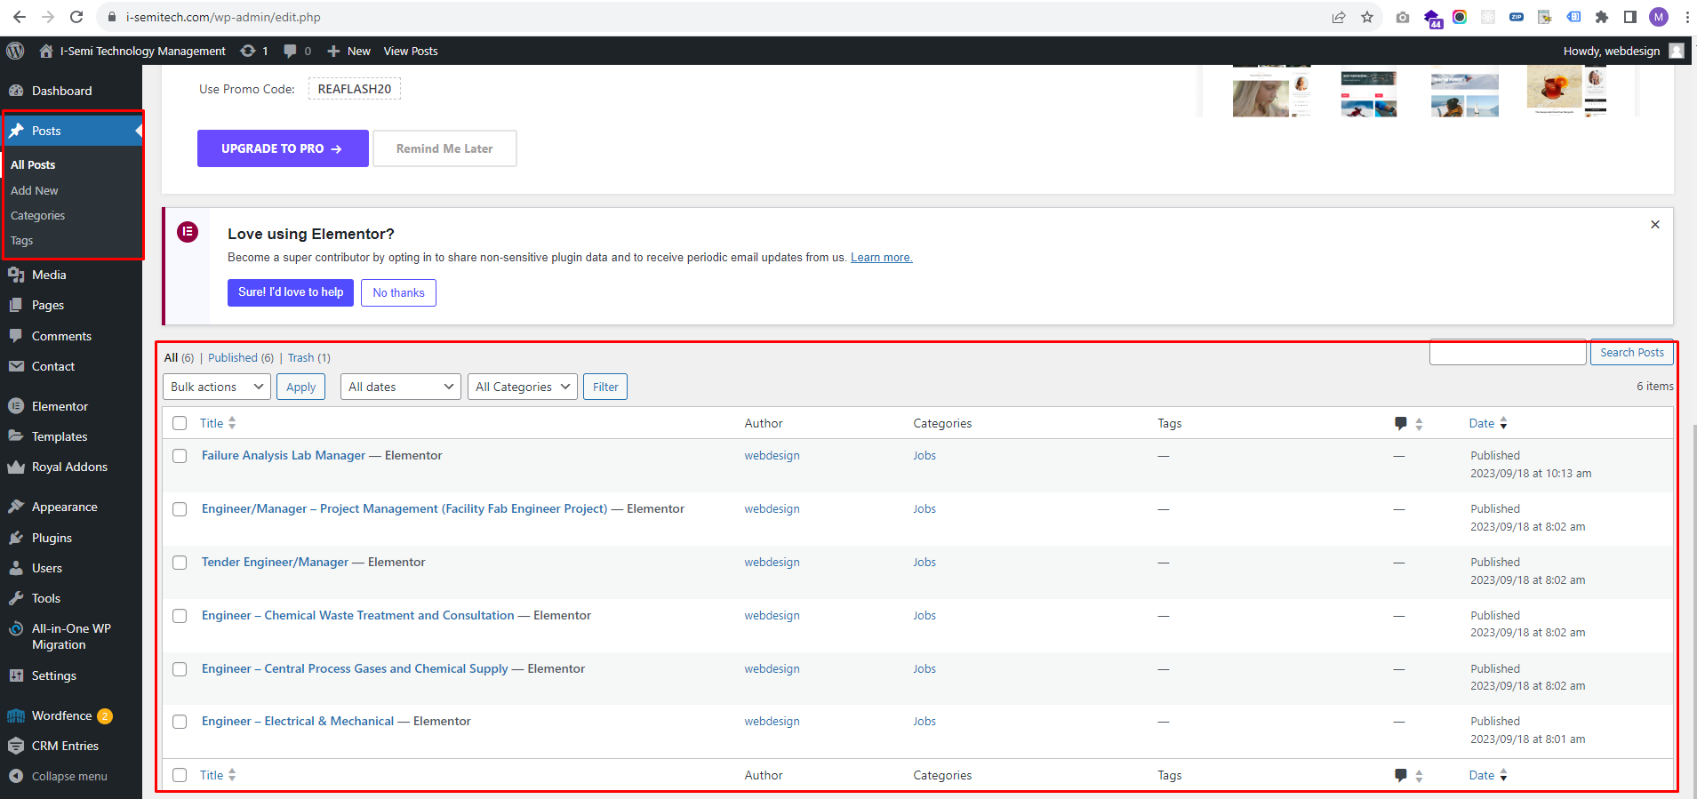

If you want to change content in single post for **Current Openings** then click on Edit with elementor and Make the changes and update as shown in the screenshot below.

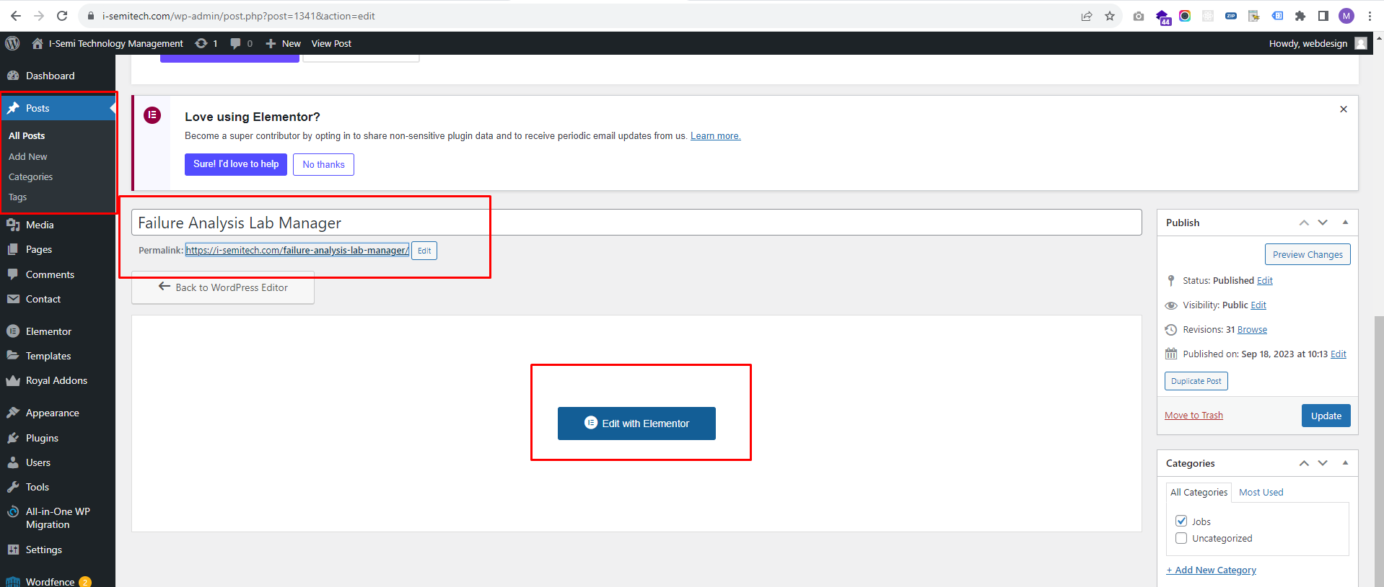

**Career Single Post**

-To change the Text or image in the single post for **Current Openings**, click on the Heading, paragraph or image, and you will find options in the left sidebar to change the corresponding Heading,Paragraph Text or image to where you clicked. Make the changes and update as shown in the screenshot below.

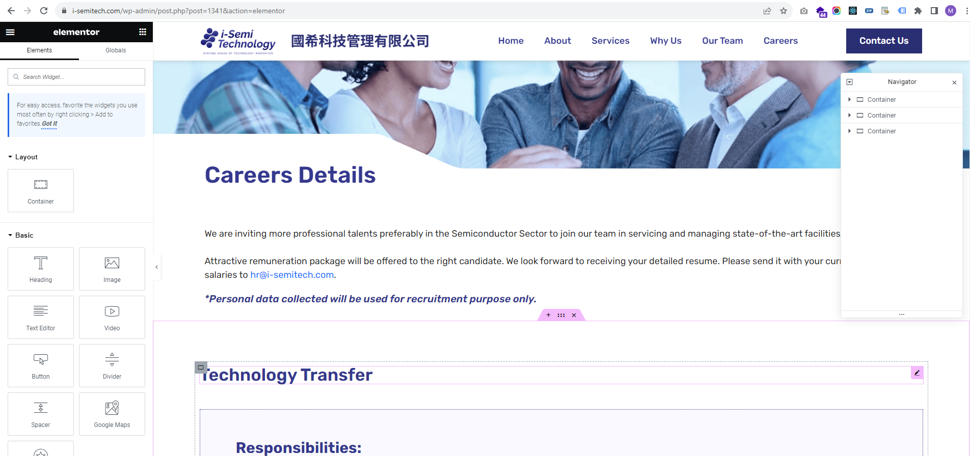

**Contact Page**

-To change the Text or image in the section, click on the Heading, paragraph or image, and you will find options in the left sidebar to change the corresponding Heading,Paragraph Text or image to where you clicked. Make the changes and update as shown in the screenshot below.

